**World Quant University**

**Professor: Tiberiu Stoica**

**Econometrics**

Nikolas Lippmann Pareschi - [nikolaslippmann@gmail.com](mailto:nikolaslippmann@gmail.com)

**Mini Project: Equilibrium Foreign Exchange in Python**

### Problem1:  VAR Model

1. Explain how macroeconomic factors influence FX evolution.

We can cite that government intervention, inflation, interest rates, current account deficits, government debt as factor that influence currencies price behavior. Governments sell and buy the currency and they have some control over supply and demand, at least in the short term. Countries which have inflation have its currency devalued compared to other countries which have less inflation. Also, investors see inflation as a risk and try to avoid hyper inflation countries like Egypt and Venezuela now days, which causes the currency to lost even more value. The difference between REAL interest rates between countries also is a proxy for valuing/devaluing. Investors seek to maximize yields and they put their money in countries with higher real interest rates (interest rates less inflation). Nevertheless, usually these countries are more unstable, so this process is more to a roller coaster. This type of investments is called the Carry Trade. Government deficits and spending usually lead to a currency devaluing. The cost of production in a country is also a proxy, one investor should produce if viable its products in Nigeria normally and not in Switzerland.

1. Calculate the equilibrium foreign exchange using cointegration (use one macroeconomic factor in the analysis).

After using the data from trading economics and Reuters to calculate the equilibrium for Brazil REAL:

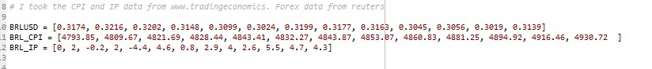

And using the code provided in Piazza I came to these results:

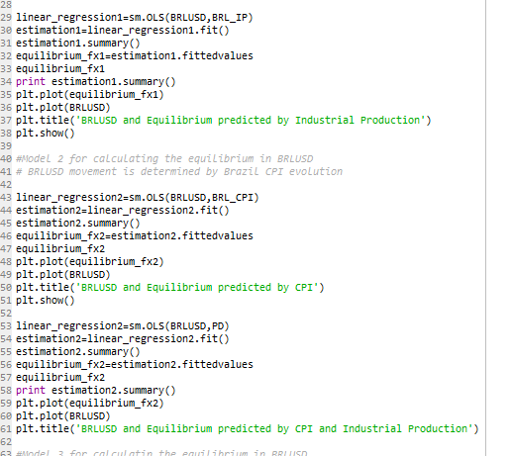

Plots:

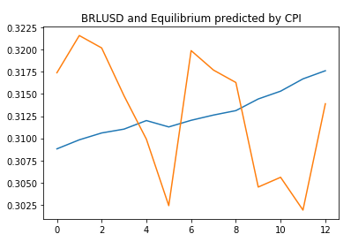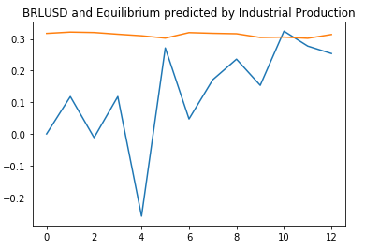

OLS Regression results for BRLUSD and IP

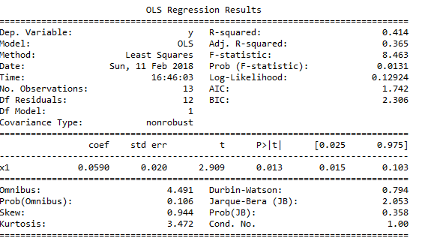

OLS Regression results for BRLUSD and CPI

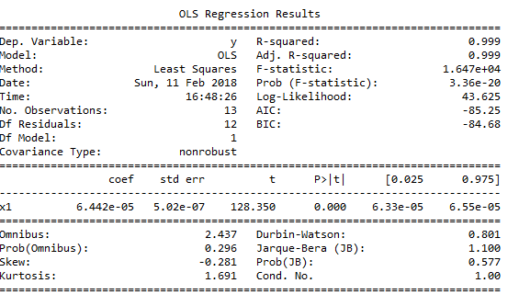

1. Calculate the equilibrium foreign exchange using cointegration (use two or more macroeconomic factors in the analysis).

Code: 

: 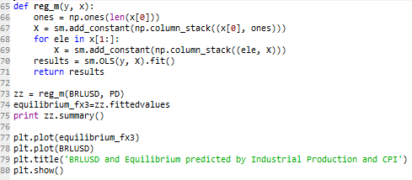 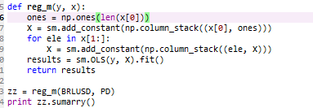

Results:

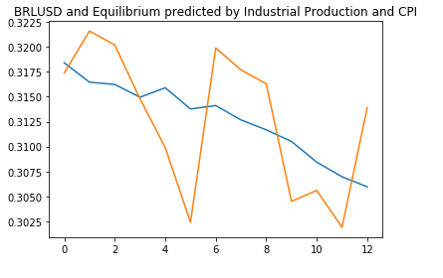

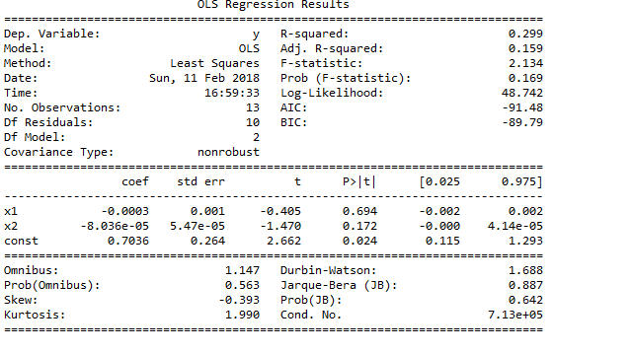

 4. Discuss your final results.

Considering the graphs I believe the multiple regression considering both CPI and IP predicted the best results. Accordingly to this result Real should devalue with time, which makes a lot of sense considering we Brazilian have the most expensive Big Mac adjusted for GDP:

